Fault isolation for a tiny poly protrusion causing single column failure in SRAM device
Daniele Radaelli, Nathan Wang, Francis Nguyen, Sabbas Daniel
Cypress Semiconductor

Among the wide array of possible failure mechanisms in IC’s, poly defect is and has been the dominant one for CMOS IC’s. However, poly defects are normally very hard to be identified. The poly layer normally lies underneath several process layers, thus making frontside probing, emission observation and deprocess difficult. Small defect size and intermittent failing behavior can make the FA work even tougher. Approaching the failure mode with the correct interpretation of partial findings obtained during the analysis will save time and lead to the final defect identification.
The present case study involves 1Mb SRAMs with low Isb specifications. The 0.13µm, shallow junction isolation, 50Å gate oxide technology includes a single polysilicon and three interconnect layers. The sample has gross electrical failure as -bitmap characterization on the MOSAID showed a single-column failure within a block (256 bits). Ebeam waveforms were obtained for the bitline (BL) and bitline-bar (BLB) signals, as well as the OUTT and OUTB SenseAmp outputs associated with the failing column and compared against their counterparts for a working column. The device was then continuously written and read at the failing and good columns (see WEb and AZ2 signals), and the BL, BLB lines were probed when the data (IO15) was set to low (labels with "IOL") and when the data was set to high (labels with "IOH"). The read cycle does not appear to have any problem; additionally during the write cycle the signals are clear, and there is no evidence of shorts between BL and BLB, as the two signals do not show any "coupling". Therefore the possibility of BL/BLB shorts is excluded. Since the column is stuck at 0, there is also the possibility that either BL is "shorted" to VSS, or BLB is "shorted" to VCC. This possibility is also excluded because during the write, BL and BLB can swing with no apparent difference with respect to the good block. The device was then preconditioned by writing a 0 or a 1 and then continuously read from Blk1 (failing) and Blk0 (good). The outputs of the Sense Amp (OUTT and OUTB) confirm that for the failing column (Blk1) there is no change with 0 or 1 data. For the BL/BLB signals it is hard to make statements because those signal have a very low amplitude during the read, and interference from other surrounding signals can affect the e-beam reading. In any case, it seems that they appear to be wiggling in the right direction. Therefore, the possibility that either the BLB contact (M1 to LI) entering the column MUX, or the MUX itself is defective.
Despite all of the effort with e-beam work, the results as described above still did not provide enough evidence to pinpoint the exact location of the fault site. Since the device presented slightly high ISB leakage of ∼200μA under nominal voltage (3.3V), therefore, front-side OBIRCH (Optical Beam Induced Resistance Change) was recommended to quickly localize the leakage source. A hot spot was put in evidence at the beginning of the failing column, just before the redundant rows (Pictures 4). More bench analysis investigation was done on the device using PicoProbing with the MPC (Mechanical Probes in Chamber) installed on the e-beam. BL and BLB were probed vs. GND, and BL showed a leaky diode( pictures 6 and 7).
Based on the Picoprobe results and the OBIRCH hot spot, there are many possibilities that the defect could occur around the faulty site (see Figure 9). The first step taken was a FIB X-section across the first dummy wordline, cutting away the poly straps to float the wordline and looking towards both end of the dummy wordline under passive voltage contrast (PVC). This would exclude the possibility of poly-contact short without cause damage to the target area if this were not the failure cause. Results of the PVC showed dummy wordline shined up, which indicates a leakage, probable protrusion to neighboring contact. Therefore, STEM was prepared to view the defect precisely. The thick TEM sample (about 0.5 μm) was prepared with FIB lift-out technique and viewed with SE mode of STEM, which confirms poly leaking by means PVC. The TE mode image shows cut-in corner of the contact on left of the dummy wordline (picture 13). The fact indicates some material occupied the space before filling of tungsten. The pre-existing material most likely is poly protrusion. Sample was then “grafted” to a wedge sample grid and ion milled. Picture 14 shows different silicon level at edge of poly lines. Silicon substrate dipping occurs during poly patterning. The fact of no dipping on the left in picture 15 indicates incomplete poly patterning, i.e. poly protrusion. Spacer Nitride is darker than poly at the target spot in Figure 14. In order to find direct evidence of “shorting” repeatedly tilting-imaging was performed. Since poly is crystal, it shows darker or brighter depending on its grain orientation to the electron beam. Fortunately, after carefully tilt to a certain angle, crystal type of contrast can be seen at the corner (See Picture 15 shows STEM bright field image). Micro-diffraction at this spot also indicates the crystal structure pattern (see Figure 16). These results suggest a poly protrusion of the dummy wordline that shorts to adjacent contact (bit line) and results in a single column failure. Picture 17 shows the schematic of the cell which indicates the defect as a resistive path connected from the long poly to the SAC.

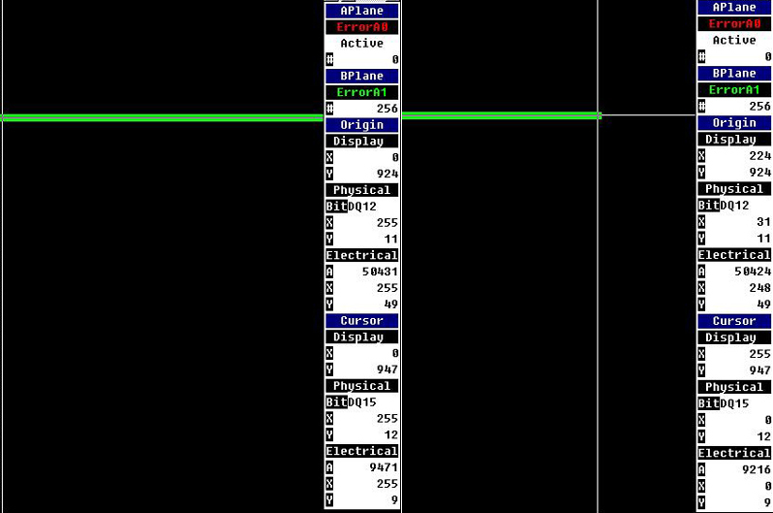  Picture 1: Device #2 Bitmap results. Failure is solid throughout – all 256 bits along the column are stuck-at-0. | 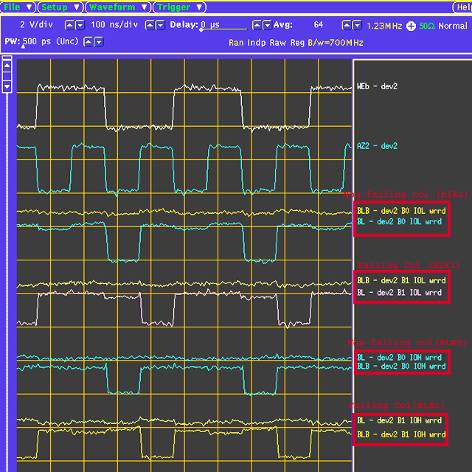  Picture 2: E-beam waveform of dev2 accessing the Sense Amp output (blk0 & blk1). | 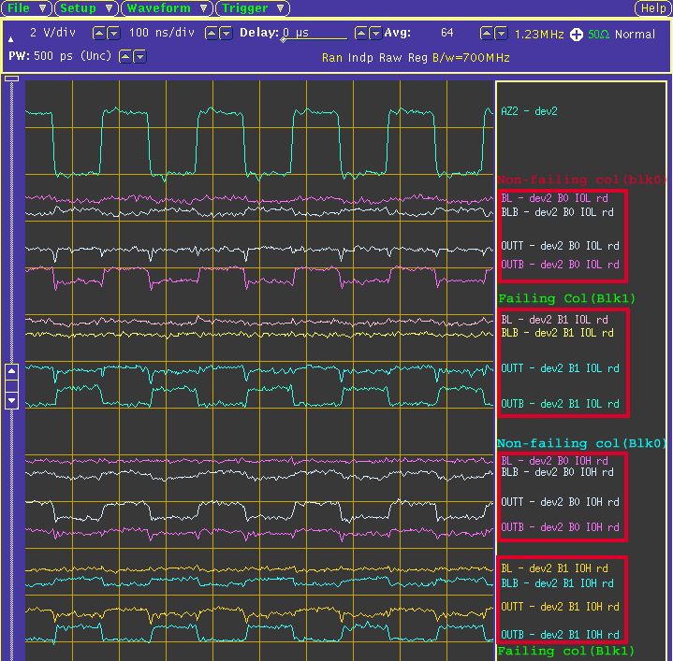  Picture 3: E-beam waveform of dev2 with the device was continuously write/read at the failing column and the good column. | 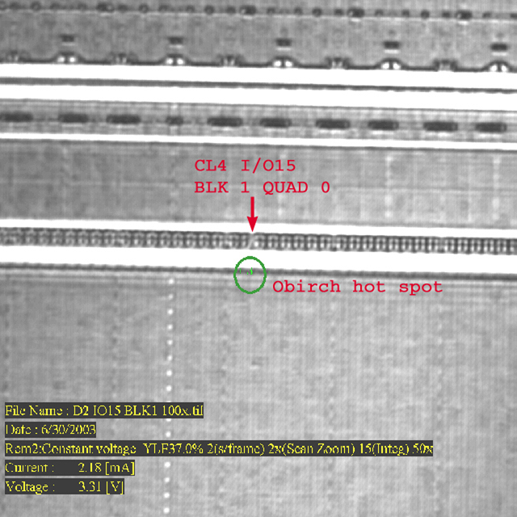  Picture 4: OBIRCH results showing a hot spot located at the binging of the failing column.
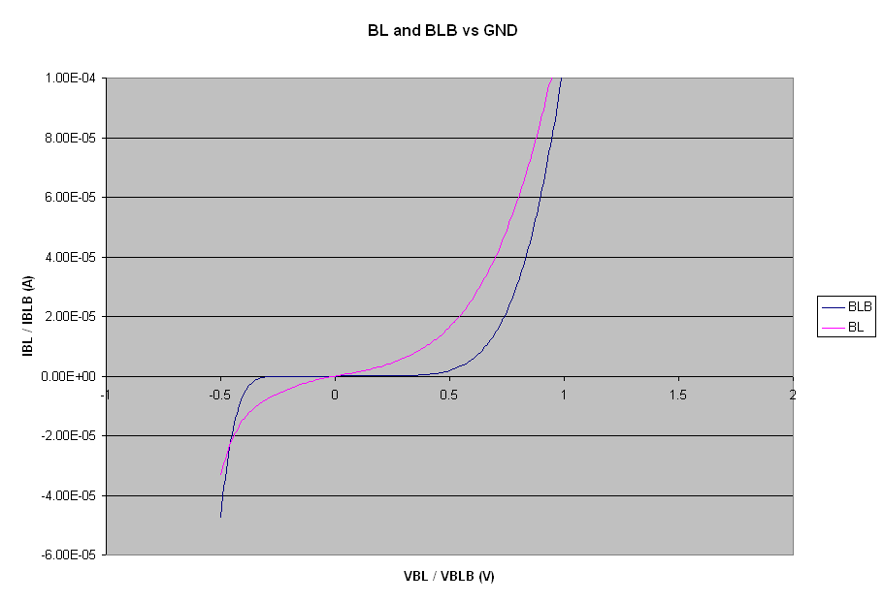  Picture 6: SEM image of the BL/BLB/VSS/ cut and the IV characteristic curve of BL and BLB probed | 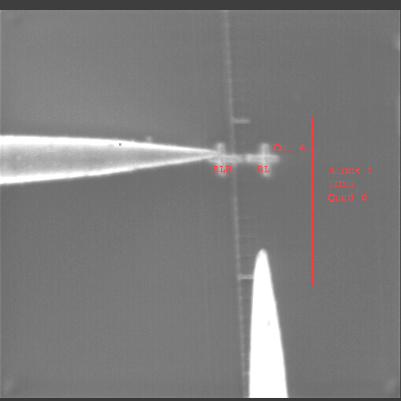  Picture 7: SEM image of the picoprobes and the BL/BLB FIB pads | 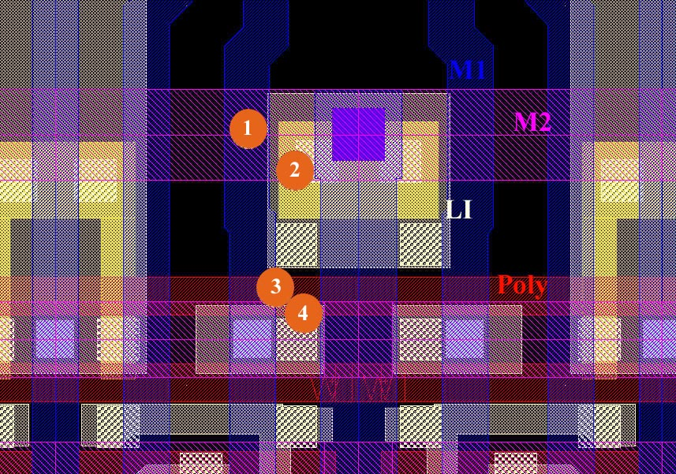  Picture 9: Device layout at the hot spot area shows the possible shorting path | 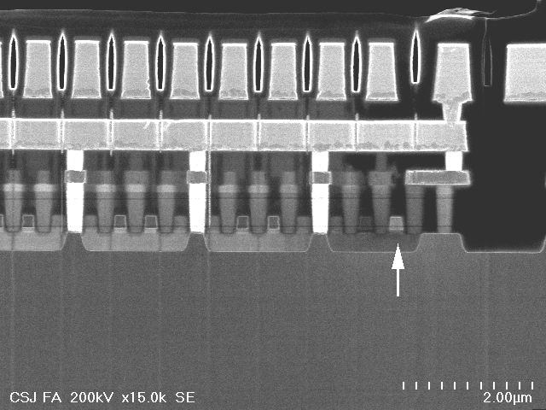  Picture 12: A SE mode image shows the target location: The leaking poly has different contrast from others because of passive voltage contrast for a thick sample.
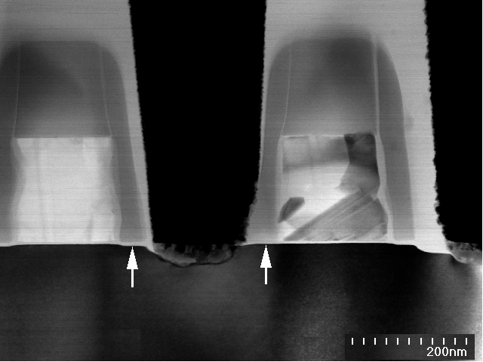  Picture 14: A TE mode image of the thin sample shows the failing long poly and the contact. The arrows point to the silicon level. The silicon should be dipped after poly patterning. No dipping of silicon indicates protrusion of poly | 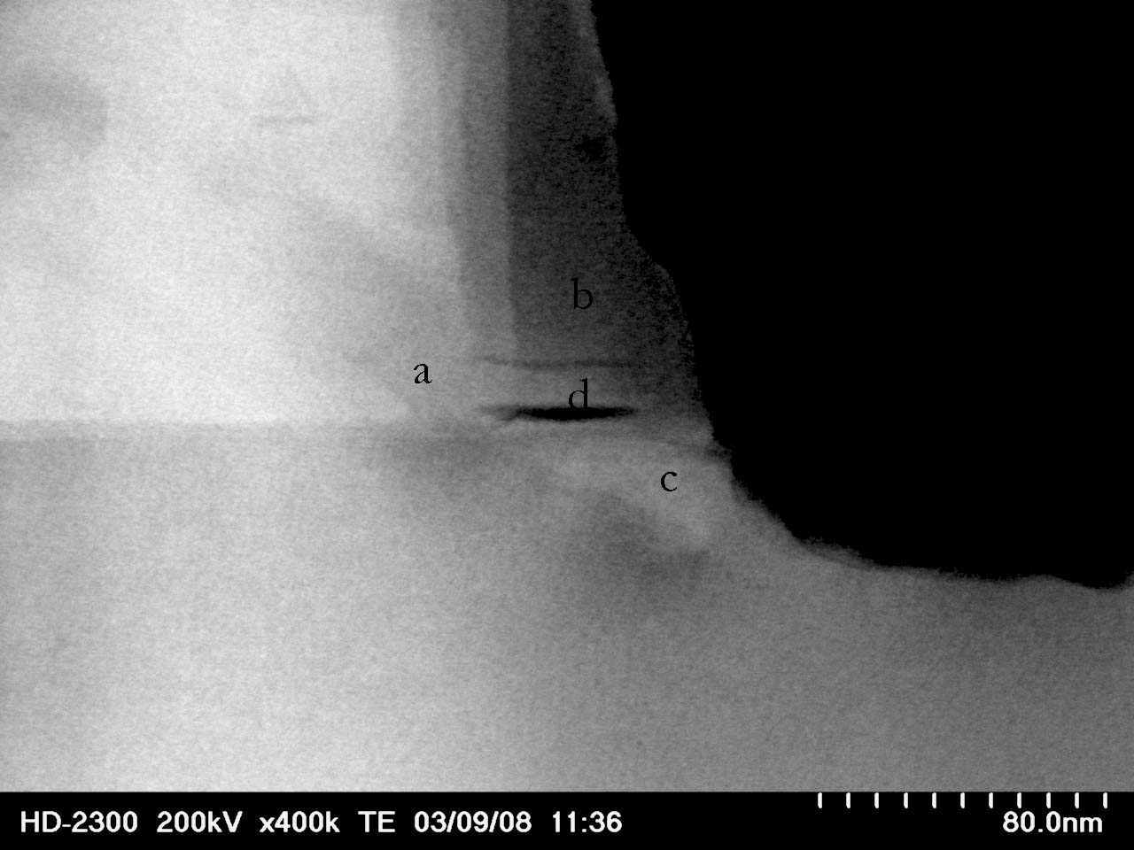  Picture 16A: A TE mode image shows the target spot. The dark fringes were seen that indicates crystal type of material. The letters indicate location of micro-diffraction | 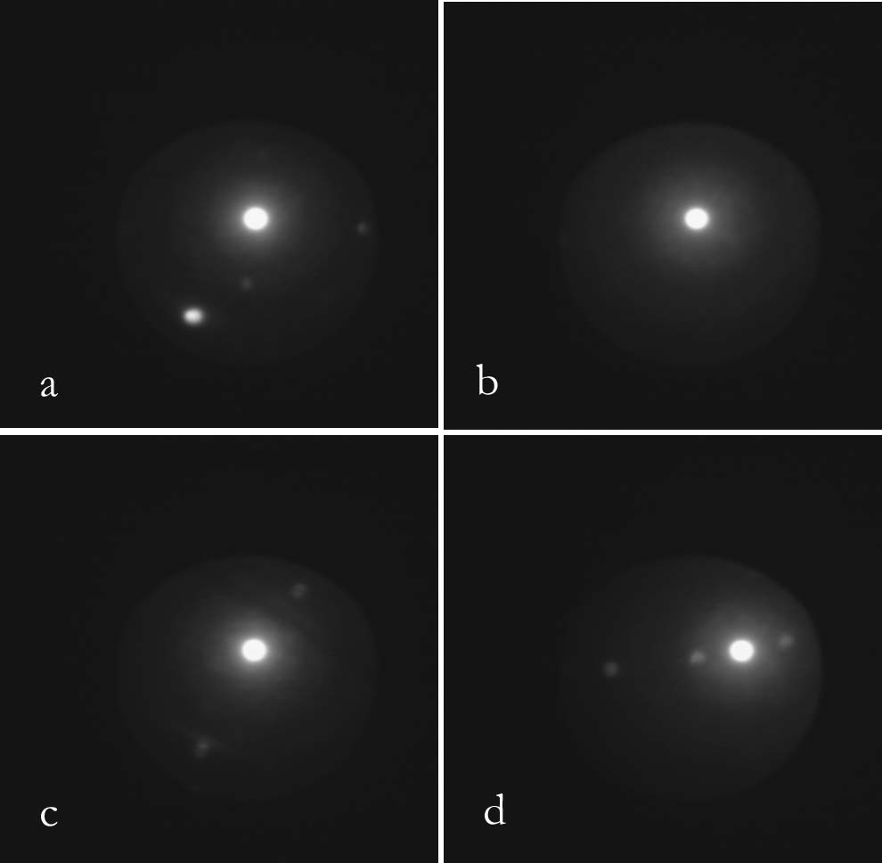  Picture 16B: Electron diffraction pattern at location A,B,C and D: A,C and D has crystal type pattern while B has amorphous type pattern | 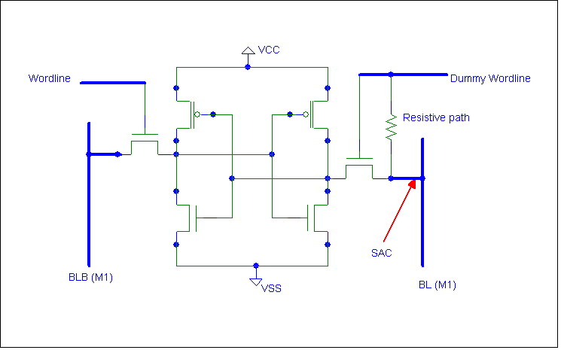  Picture 17: Schematic of the cell showing the resistive path between the long poly and the SAC
Key Words: SRAM, Poly protrusion, defect approaching,

